Nexus Aquarium

*User Guide*

|  |  |  |
| --- | --- | --- |
| **Supervisor.** | **Miss Fariha** | |
| **Batch.** | **2310F1** | |
| **Group.** | C | |
| **Serial No.** | **Enrollment Number** | **Student Name** |
| 1. |  | Saeed Ur Rehman |
| 2. |  | Basil Israr |
| 3. |  | Masab Khan |
| 4. | - | ­- |



1. **Home** (*index (1).html*)

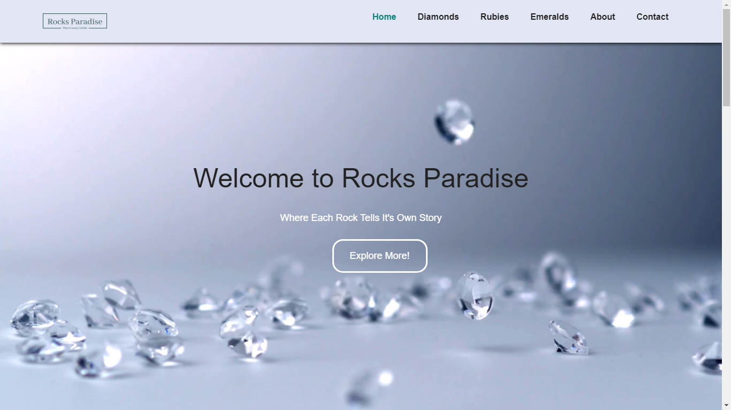

***Figure 1: Home page to Rocks Paradise***

* By clicking (Explore More) button user while redirect to the main webpage.

1. **Navbar (index (1).html)**

**

***Figure 2: Navbar***

We have given seven essentials. By clicking any of the essential’s and redirect to the linked page. (0. Index (1).html)

1. **Diamonds(diamondshtml)**

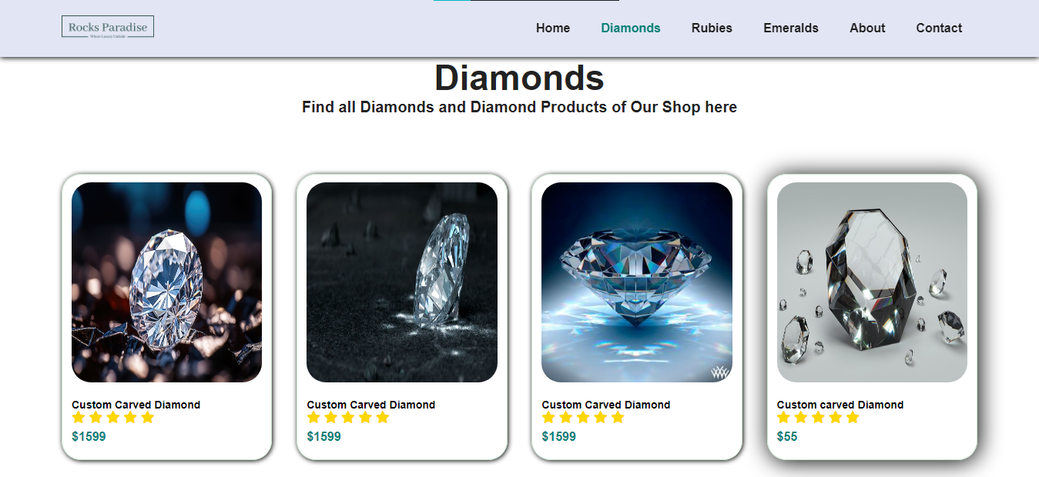

***Figure 3: Diamonds***

**

** Explore different Diamonds in both raw and shaped form.

** Discover all about jewelleries of Diamonds.

**4.****Rubies (index (1).html)**

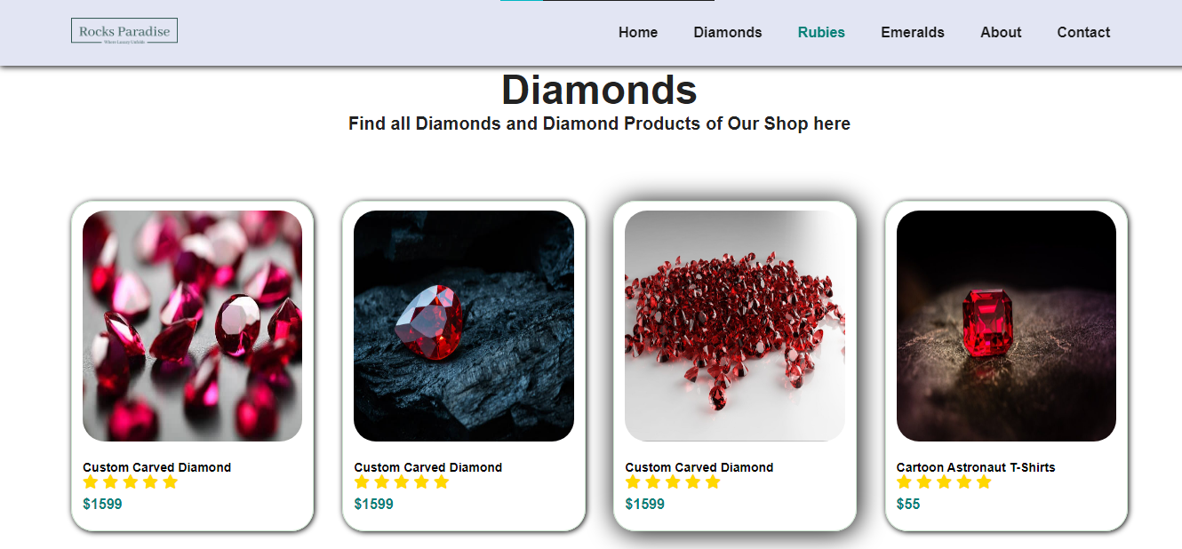

***Figure 4: Rubies***

** Explore different Rubie in both raw and shaped form.

** Discover all about jewelleries of Rubies.

***5.Emeralds (index (1).html)***

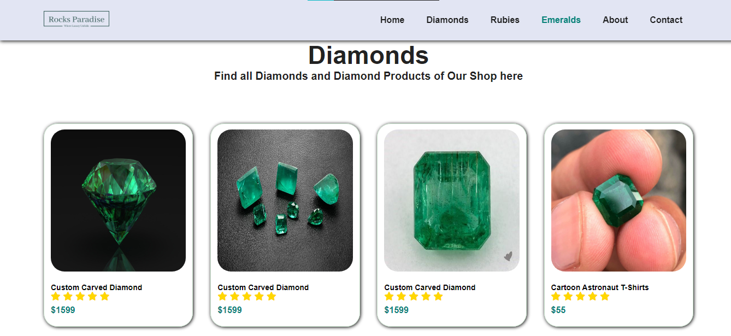



***Figure 5Rubies***

** Explore different Rubie in both raw and shaped form.

** Discover all about jewelleries of Rubies.

***6. About Us:***

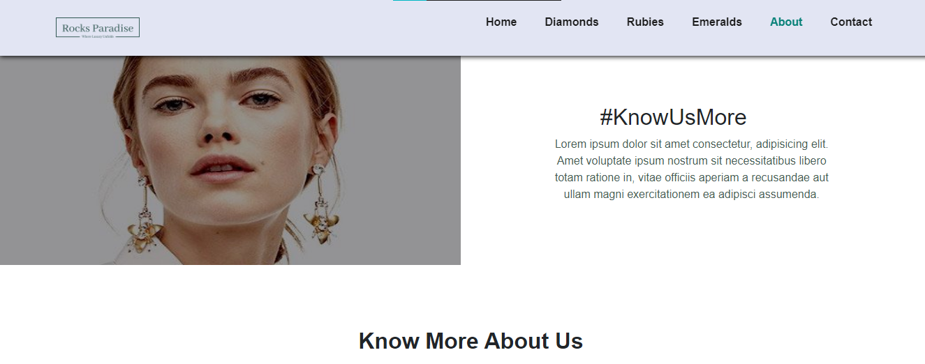

***This Page Helps you to Know more About us .***

***7. Video link:***

***Figure 7:Conatct Us***

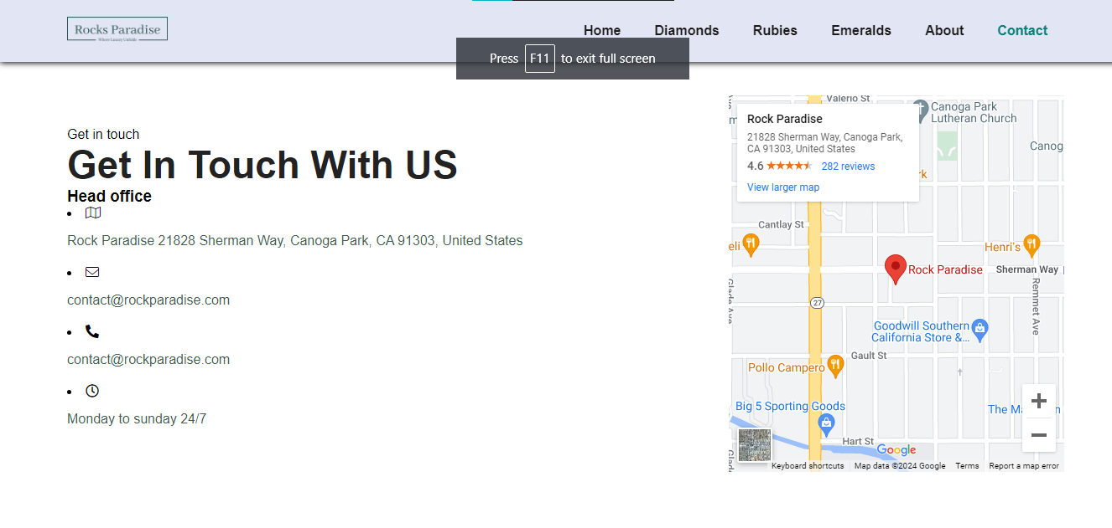

***You Can Contact US through this page***

